Topic 4.9

POLYMERS

Formation of addition polymers
Properties and uses of addition polymers
Formation of condensation polymers
Properties and uses of condensation polymers
Disposal and recycling

ADDITION POLYMERS

i) Formation of addition polymers

Addition polymers are formed from alkenes.

Alkenes can be made to join together in the presence of high pressure and a suitable catalyst. The π-bond breaks and the molecules join together. No other product is formed, and so this is known as addition polymerisation. Since the polymers are made from alkenes they are also known as polyalkenes.

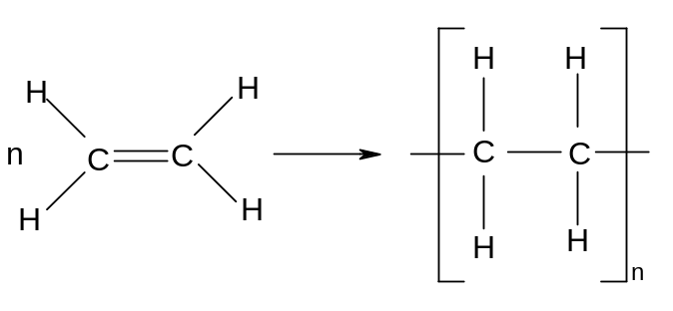
ethene → polyethene

The product of this addition process is a very long hydrocarbon chain.
Addition polymers can be made from any alkene:

Eg propene poly(propene)
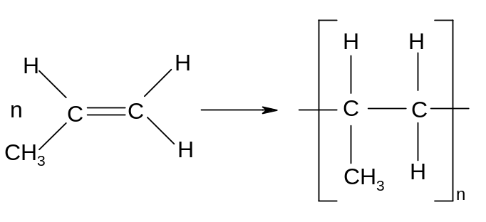

Eg but-2-ene poly(but-2-ene)
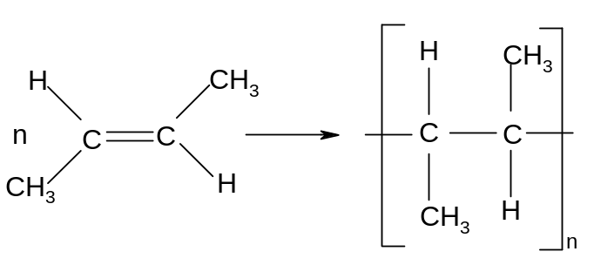
Many useful polymers are addition polymers made by this process:

- polyethene is used in plastic bags and in crates

- polypropene is used in plastic tubing

- polychloroethene (polyvinylchloride) is used in waterproof clothing and records
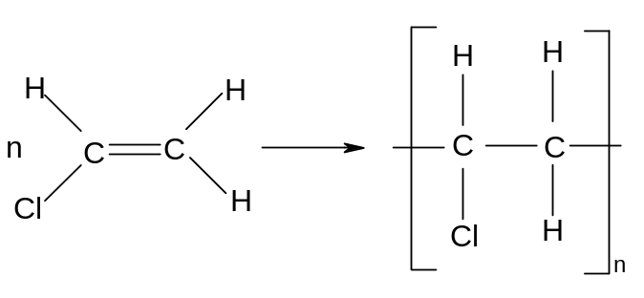
- polyphenylethene (polystyrene) is used in packaging
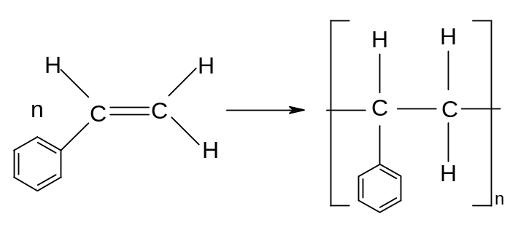

The most favourable conditions for the polymerisation of alkenes can be deduced from Le Chatelier's principle, if two points are noted:
- the reaction involves breaking π-bonds only, and many σ-bonds are made. The reaction is thus exothermic.
- The reaction involves a reduction in the total number of moles:

Since the reaction is exothermic, the best yield is obtained at low temperature. Since the number of gas moles decreases, the best yield is obtained at high pressure.

Addition polymerisation reactions are carried out at high pressure in the presence of a suitable catalyst.

ii) Properties of addition polymers

Addition polymers (polyalkenes) are long chain hydrocarbons which are saturated and non-polar. Their structure results in their having a number of characteristic properties:

- Since the hydrocarbon chains are often very long, the Van der Waal's forces between the chains are often very strong and the polymers have relatively high melting and boiling points. Since the chain length is variable, most polymers contain chains of a variety of different lengths. Thus the Van der Waal's forces are of variable strength and these polymers tend to melt gradually over a range of temperatures rather than sharply at a fixed temperature. As the chains are not rigidly held in place by each other, polymers tend to be reasonably soft.

- Since the chains are non-polar, addition polymers are insoluble in water. Since the intermolecular forces between the molecules are strong and the chains are often tangled, they are generally insoluble in non-polar solvents as well. In fact the long saturated hydrocarbon chains result in polyalkenes being very unreactive generally, as they cannot react with electrophiles, nucleophiles or undergo addition reactions.

This results in their widespread use as inert materials - they are very useful as insulators, as packaging and in making containers.

However their low reactivity means that they are not easily decomposed in nature and as a result have a very long lifetime. Such substances are said to be non-biodegradable, and constitute an environmental hazard as they are very persistent in nature and thus difficult to dispose of.

- The density and strength of addition polymers varies widely. They depend to a certain extent on the length of the hydrocarbon chain, but depend much more strongly on the nature and extent of the branching on the chain.

Polymers which have very few branches are very compact and the chains can thus pack together very efficiently:

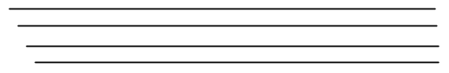

These polymers tend to have a very high density. Since the chains are closely packed, the Van der Waal's forces between the chains are strong and these polymers tend to be stronger and harder as well.

Polymers which are highly branched cannot pack together as well, and there tend to be large spaces in the structure:
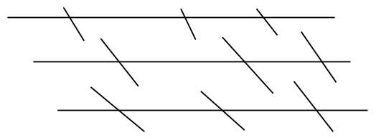
These polymers have a much lower density. Since the chains are not closely packed, the van der Waal's forces between the chains are weaker and these polymers tend to be weaker and softer.

CONDENSATION POLYMERS

i) Polyesters

It has been shown that if a carboxylic acid or acyl chloride is reacted with an alcohol, then an ester is formed and a small molecule is lost.

Eg ethanoyl chloride + ethanol → ethyl ethanoate + HCl
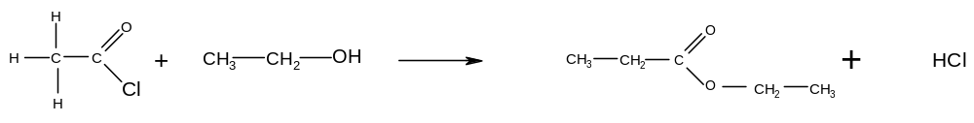

Eg benzoic acid + methanol → methyl benzoate + H₂O
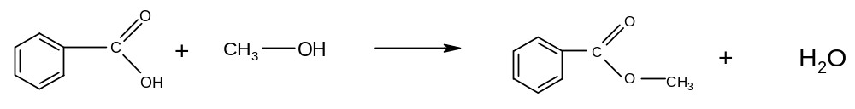

These are examples of condensation reactions – combination of two or more molecules followed by the elimination of a small molecule.

It follows that if a dicarboxylic acid is reacted with a diol, then the -COOH group at each end of the dicarboxylic acid should join to an -OH group, and the -OH group at each end of the diol should join to a -COOH group. It should therefore be possible for all the molecules to link together and form a polymer.

Eg benzene-1,4-dicarboxylic acid and ethan-1,2-diol
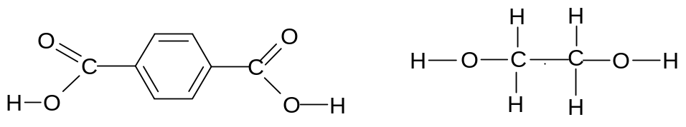
benzene-1,4-dicarboxylic acid ethan-1,2-diol

These two compounds can link together to form a polymer, and water is given off:
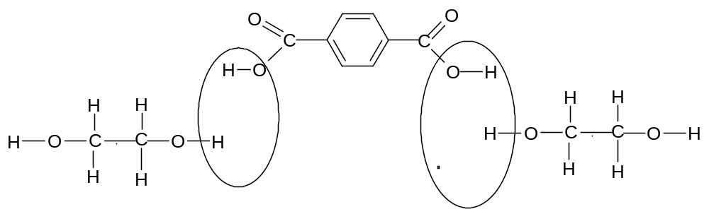
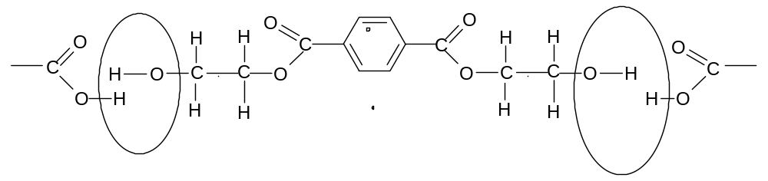

This polymer can be represented by the following repeating unit:
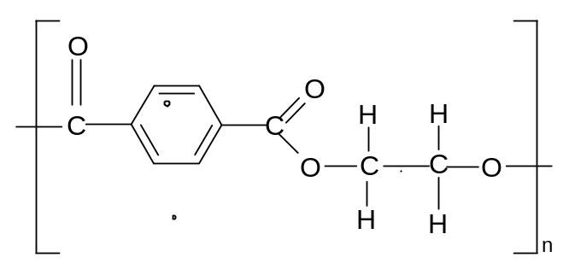

The overall equation can be represented as:
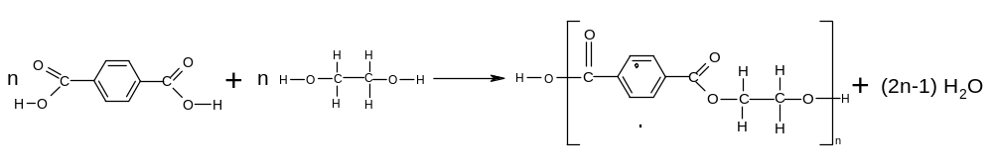

The monomer units are linked together by the ester group:
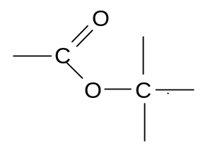
Polymers containing this type of linkage are therefore known as polyesters.

The above polymer is known as terylene. It is used in fire-resistant clothing (eg racing drivers)

The same polyester can also be formed by the combination of a diacyl chloride and a diol:

Eg benzene-1,4-diacyl chloride and ethan-1,2-diol
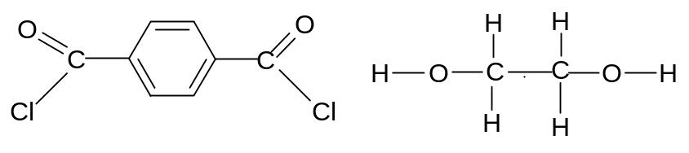
These two monomer units link together to form the same polymer. The only difference is that HCl instead of H₂O is given off.

The overall equation can be represented as:
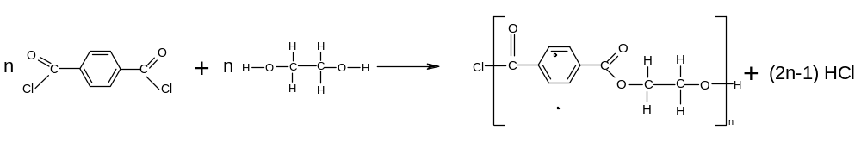

The polymerisation reaction with diacyl chlorides produces a much better yield than the corresponding polymerisation reaction with dicarboxylic acids. This is because acyl chlorides are more reactive than carboxylic acids and also because the HCl produced is gaseous and thus escapes, making the reaction more difficult to reverse.

Thus dicarboxylic acids are generally converted to diacyl chlorides (by addition of PCl₅) before a polymerisation is carried out.

Another example of polyester formation is:

Ethanediacyl chloride and propan-1,2-diol
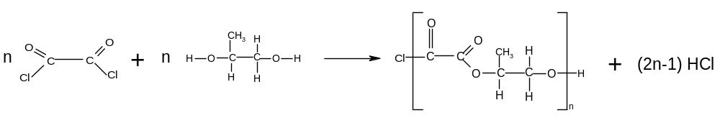
ii) Polyamides

It has been shown that if a carboxylic acid or acyl chloride is reacted with a primary amine, an N-substituted amide is formed:

Eg propanoic acid + ethylamine == N-ethylpropanamide + H₂O

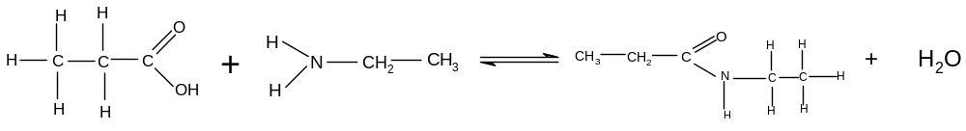

Eg ethanoyl chloride + 1-aminopropane → N-propylethanamide + HCl

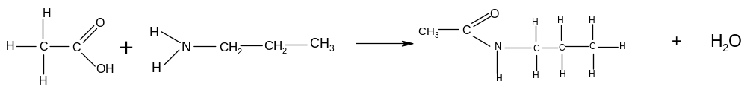

It follows that if a dicarboxylic acid is reacted with a diamine, the -COOH group at each end of the dicarboxylic acid with join to an -NH₂ group, and the -NH₂ group at each end of the diamine will join to a -COOH group. It should therefore be possible for each of the molecules to join together and form a polymer.

Eg hexanedioic acid + 1,6-diaminohexane
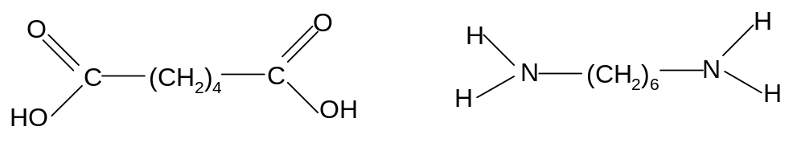
These two compounds can link together to form a polymer, and water is given off.
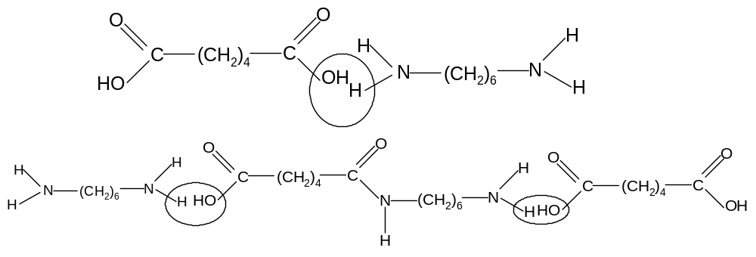

The polymer can be represented by the following repeating unit:
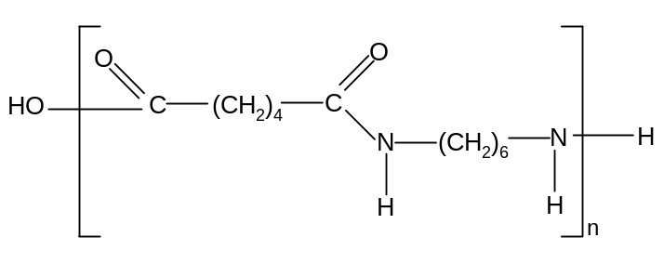

The overall equation can be represented as:
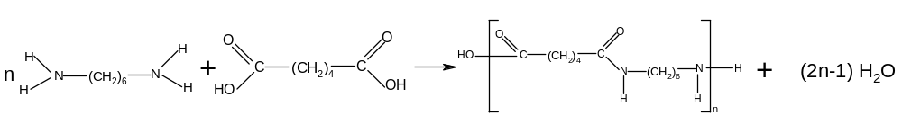
The monomers are linked together by the amide, or peptide link:
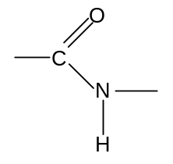
Polymers containing this type of linkage are therefore known as polyamides.

The above polymer is known as nylon 66. It is a man-made fibre used in clothing

The same polyamide can be formed by the combination of the diacyl chloride and the diamine:
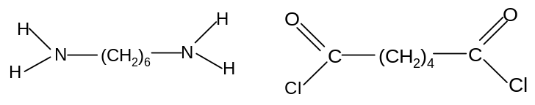
These two monomer units link together to form the same polyamide. The only difference is that HCl is given off instead of water.

The overall equation can be represented as:
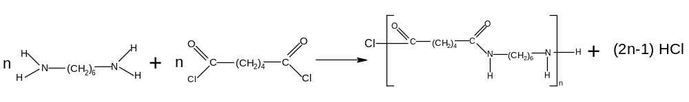

The polymerisation reaction with diacyl chlorides gives a much better yield than with the corresponding dicarboxylic acid for the same reasons as with the polyesterification reaction. Dicarboxylic acids are therefore converted to the corresponding diacyl chloride (by addition of PCl₅) before the polymerisation is carried out.

Another example of polyamide formation is:

Butanedioyl chloride and 1,2 diaminopropane
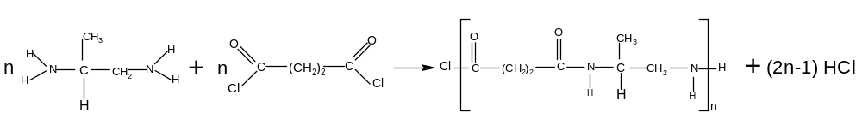

Polyesters and polyamides are collectively known as condensation polymers because they are the product of condensation reactions.

iii) Properties and uses of condensation polymers

Condensation polymers tend to consist largely of straight chains with few branches. This is because they are formed by reactions with heterolytic mechanisms, which are much less random than homolytic mechanisms. Addition polymers are formed by free radical addition mechanisms which always lead to a variety of products and consequently much more branching.

Since there are few branches in condensation polymers, they are usually linear and can thus pack closely tegether. Condensation polymers are therefore more rigid than addition polymers and have a higher tensile strength.

The strength of the intermolecular forces between the different chains in polyamides is further enhanced by the presence of hydrogen bonding.
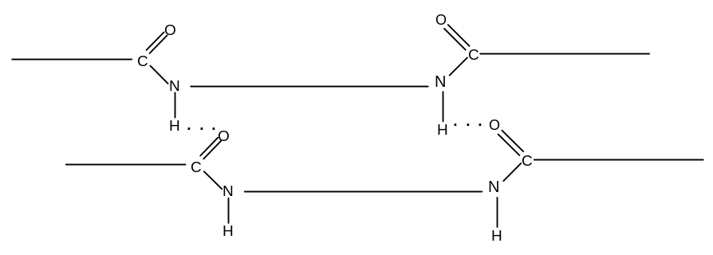

Polyamides are therefore generally very strong. In some natural polyamides, such as proteins, intramolecular hydrogen bonding is possible and the molecule curls up to form a helical structure:
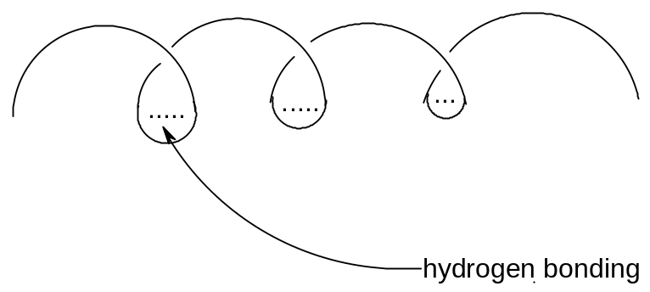

Polyamides and polyesters are both used largely in high-strength synthetic fibres.

Polyesters are used as wool and cotton substitutes in clothing (esp jumpers, T-shirts, shirts etc) and also in carpets and rugs. Bullet-proof vests and some flame-retardant clothing are made from polyesters.

Polyamides are more elastic and used in underwear, fishing nets and other synthetic fibres.

Perhaps the most important difference between condensation polymers and addition polymers is that condensation polymers are made up of chains containing polar bonds; i.e. C-N and C-O bonds which link every polymer unit. These polar carbon atoms can be readily attacked by nucleophiles and as a result the polymers can be broken up and the constituent monomers reformed. Condensation polymers are hence biodegradable, and so clearly constitute a smaller environmental hazard than addition polymers, whose chains are made up entirely of non-polar C-C bonds and which are hence non-biodegradable.

The break-up of these polymers is carried out in aqueous solution and can be classed as hydrolysis reactions:

Polyesters are best hydrolysed in strongly alkaline conditions, in which they undergo saponification:
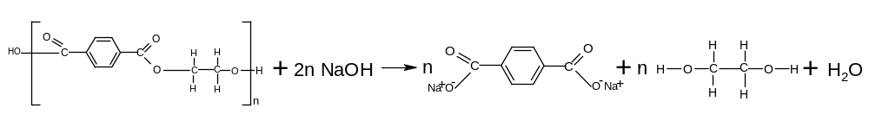

Polyamides are best hydrolysed in strongly acidic conditions:
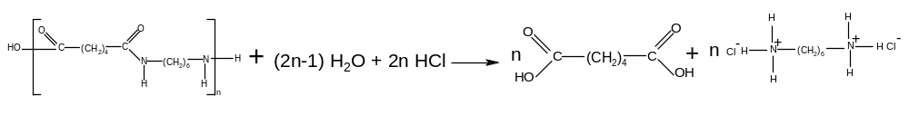

The biodegradability of condensation polymers may compromise their effectiveness, since physical and chemical durability is one of the reasons for their widespread use. A balance must be struck between practical durability and long-term biodegradability.

DISPOSAL AND RECYCLING OF POLYMERS

The disposal of non-biodegradable polymers is a significant problem. There are three options:
- burying in landfill sites
This is widespread in all developed countries but is a completely unsustainable practice, as each landfill site will eventually fill up. Landfill sites are also unsightly and unhygienic.
- burning
This is also common, but burning polymers releases greenhouses gases such as carbon dioxide and can also release toxic gases, depending on exactly what polymer is being burned
- recycling
This is environmentally preferable to burying or burning, but it is not easy. Different plastics need to be collected, separated and cleaned. They then need to be melted down before being recast into the new item. Often this process can cost more than it costs to manufacture the plastic from crude oil.
Some plastics cannot be melted – they burn or harden instead of melting. It is even more difficult to recycle these plastics as they can only be used in the same shape in which they were originally cast.

The above problems mean that the continued manufacture of non-biodegradable polymers is a cause for environmental concern.

Biodegradable polymers decompose naturally, so burying them is slightly less environmentally unsustainable as they will eventually break down.
They can be recycled, broken down into their original components and reused, but they still need to be collected, separated and cleaned.

SUMMARY OF POLYMER FORMATION AND HYDROLYSIS REACTIONS

Type of reaction | Mechanism
1. Addition polymerisation (alkenes → polyalkenes)  conditions: high temperature, Ziegle-Natte catalyst  equation:  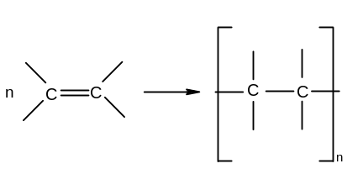  2. Condensation polymerisation  a) polyesters  dicarboxylic acid + diol → polyester  conditions: H₂SO₄, heat under reflux  equation:  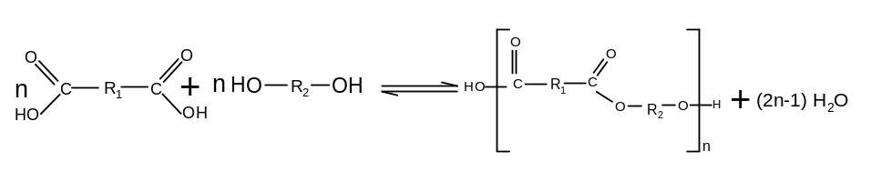  or  diacyl chloride + diol → polyester  conditions: room temperature  equation:  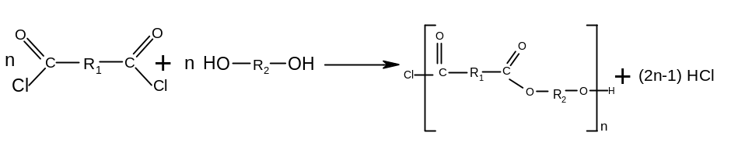  b) polyamides  dicarboxylic acid + diamine → polyamide  conditions: warm, reflux  equation:  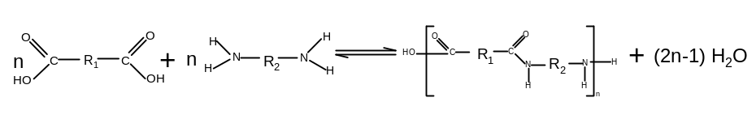  or  diacyl chloride + diamine → polyamide  conditions: room temperature  equation:  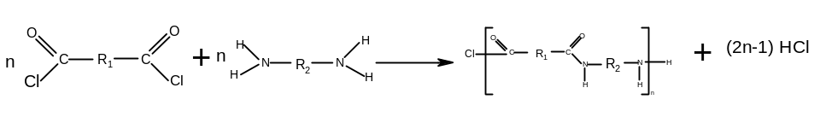  3. Hydrolysis of condensation polymers  a) polyesters  reagents: NaOH(aq)  conditions: heat  equation:  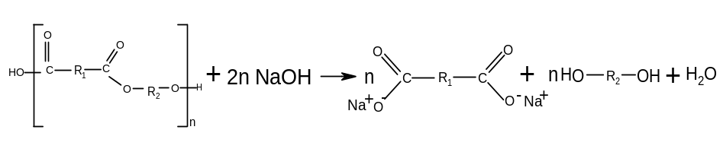  b) polyamides  reagents: HCl(aq)  conditions: heat  equation:  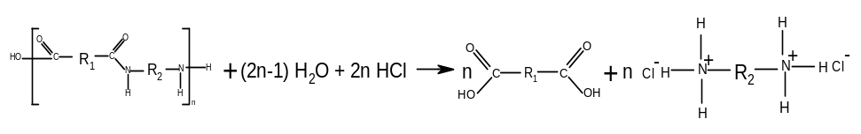 | Free radical addition  (not required)  Nucleophilic addition-elimination  (not required)  n/a  n/a

